Title. Subtitle (papers/workshops)

Name Surname
Affiliation, Country, email
Name Surname
Affiliation, Country, email

Abstract - This template is set up to help you prepare your paper for correct online publication in the ESREA Triennial 2022 Conference Proceedings. Please do not make any changes or modifications to the page layout or paragraph styles. If you experience difficulty using this template, please contact redazione@ledizioni.it. Remember that there will be no editing: be sure that your English is good enough and there are no typos.

KEYWORDS: Insert 3 to 5 keywords, separated by a comma and with a final dot.

FIRST PARAGRAPH
Copy your text here; this will allow you to maintain the established paragraph styles. Avoid modifying or adding new paragraph styles or commands. If you have a pre-set layout style, choose this as the new setting.

- SECOND PARAGRAPH
  - Fonts
Please use Times New Roman for the text and Helvetica for the headings. Using the appropriate paragraph styles will ensure proper use of font family and size. All contributions should use 10pt Times New Roman for the body text and Line spacing: 1.5
For graphics, Times (in roman, bold or italic), symbol font should be used.
  - Title, Authors, and Affiliations
If you follow the template, the title will be set in 14pt bold upper and lower case letters and left aligned on the page.
The names of the authors and their affiliation and mailing address will be listed in 10pt upper and lower case letters.
  - Section Headings
Section headings should be numbered, 11pt bold all upper case letters and left aligned in the column.
Widow and Orphan Control. After headings, the text follows with no breaks.

  - Subsection Headings
Subsection headings should be numbered (such as 2.4. for this one), have 11pt upper and lower case letters and be left aligned in the column. Please avoid more than 3 subsections.
  - Paragraph Text
Paragraphs are in 10pt Times Roman, justified. The beginning of each paragraph should be indented 3mm (.13in).
Do not use footnotes, but endnotes and only if strictly necessary.
Please use single quotation marks and punctuation before the closing quotation marks. Larger sections of quoted text should be set off from the running text by a blank line before and after the quoted text, and the text should be indented on the left-hand side. No quotation marks should be used for these block quotes.
Acronyms must be defined the first time they are used.
For references, please follow the APA7 system.
  - Graphics
As this is an online publication, color can be used both for text and for photos or graphics. However, avoid pale yellow and light colors.

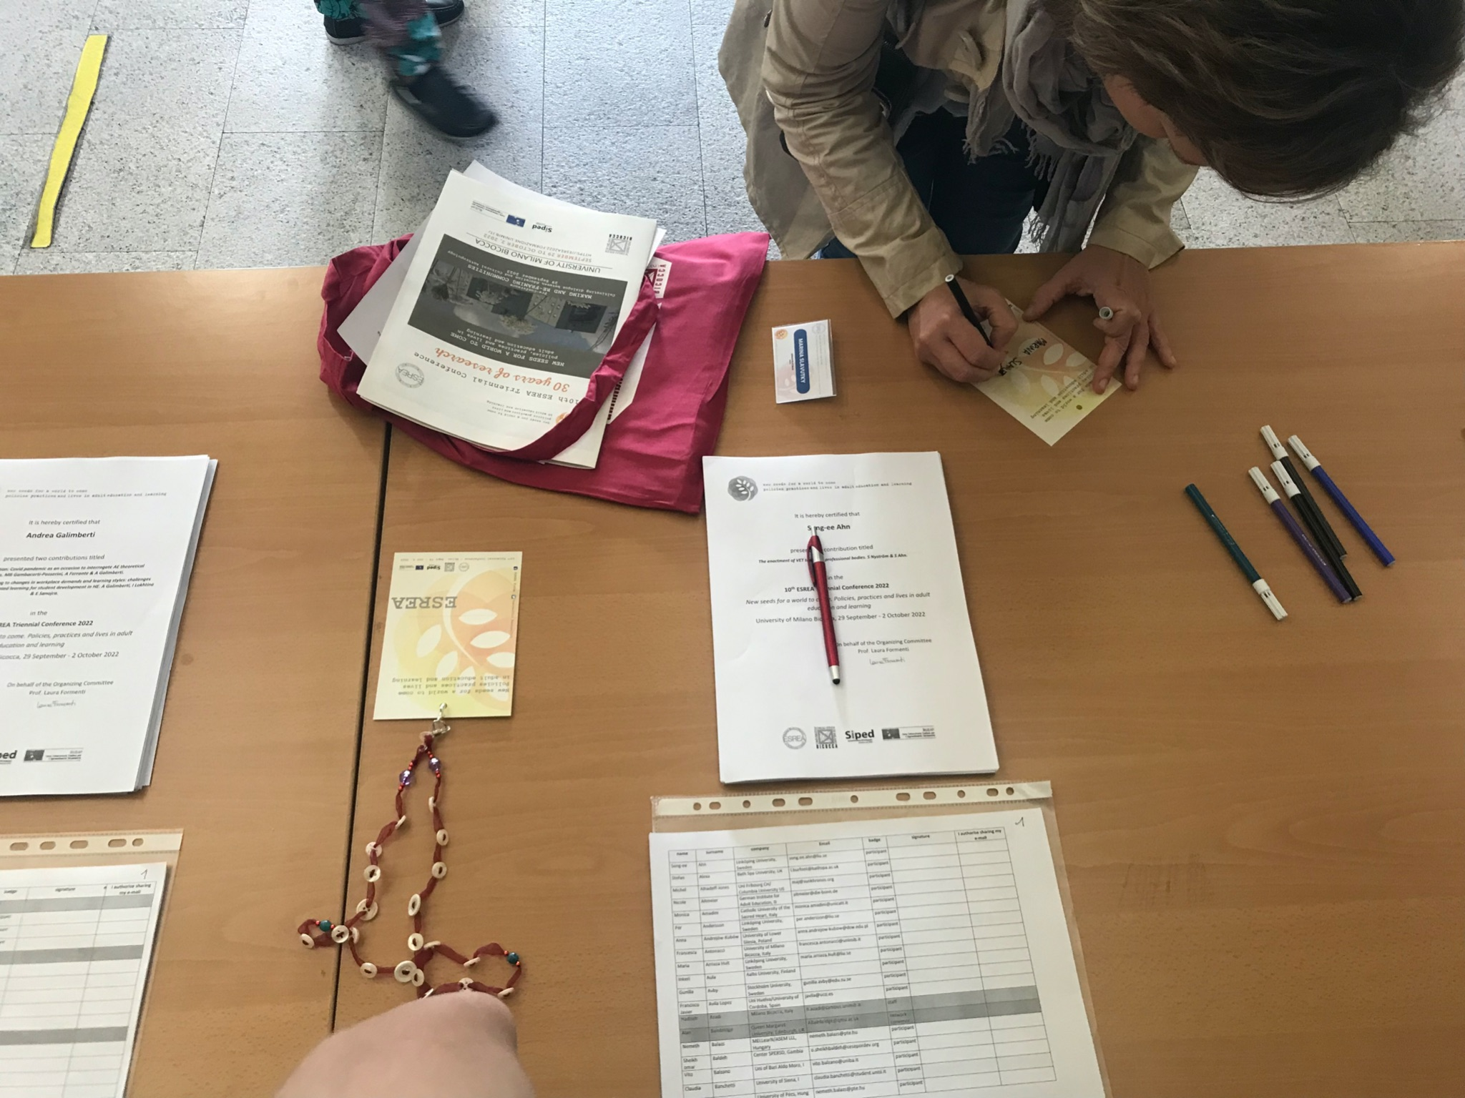

Figure 1: Example of a figure

  - Figures and Tables
Place figures and tables in the center of the page, as close as possible to the place of their mention. Every image must be quoted in the text (for example, see Figure 1). Lettering in figures and tables should be large enough to reproduce clearly, using only the approved fonts. Use of non-approved fonts will lead to problems when the files are processed and may cause loss of information.
All figures and tables must be given sequential numbers (1, 2, 3, etc.) and have a caption placed below the figure or table (see example), using 10pt Times New Roman and centered.

- FINAL CHECKLIST FOR ELECTRONIC PUBLICATION

Please check:
- Proper layout?
- Correct fonts?
- Indication of images in-text and corresponding images sent separately?
- Correct format of title, authors list, and affiliation?

Acknowledgments

The authors wish to thank Ledizioni for their guidance in preparing this template.

Work supported by the Department of Education.

References

Please follow the APA7 system.

